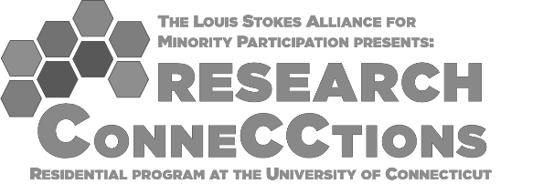**In addition to the completed application form, please send an unofficial transcript to:** [**Sarah.Farrell@uconn.edu**](mailto:Sarah.Farrell@uconn.edu)**.**

**Applicant Name:** Click or tap here to enter text.

**Date of Birth*:** Click or tap here to enter text.*\*Must be at least 18 years old to participate*

**Email**: Click or tap here to enter text.

**Mailing Address:** Click or tap here to enter text.

**Phone:** Click or tap here to enter text.

**Name of Current Institution**: Click or tap here to enter text.

**What is your current or desired field of study? (Mechanical Engineering, Biological Sciences, Environmental Sciences, etc.)** Click or tap here to enter text.

**What is the four-year institution you hope to transfer to?** Click or tap here to enter text.

**For the purpose of this grant, underrepresented races or ethnicities in STEM are defined as: Black or African American, Hispanic, American Indian, Alaskan Native, Native Hawaiian, and Native Pacific Islander. By checking the box below, the applicant agrees to the statement: *"I self-identify as part of a population underrepresented in STEM programs."***

I agree with the statement above.

**Race/ethnicity: I self-identify as:** Click or tap here to enter text.

**For housing purposes, please indicate your gender. I self-identify as:** Click or tap here to enter text.

**I am a U.S. citizen or Permanent Resident:**

I agree with the statement above.

**In the space below, please address your interest in attending the LSAMP Research ConneCCtions. We encourage you to include any relevant details about your background in shaping your future goals. Please limit statement to 250 words.**

Click or tap here to enter text.